Upon arrival of the JDA screens at LGR, inspections were performed to evaluate production model differences. Once the discrepancies were noted, items in question were either updated or modified to match established production model components. The main operational differences are as follows:
- Sweep Tube (cleaning device) had different drive chain, mounting configuration, and brushes. We updated all items to the latest specifications, installed new cleaning brush design, and adjusted tension so the cleaning device doesn’t lose contact with the bar screen
- Approximately 70 perforated plates on each screen were found to have only 20% open flow design. Production model ESBS plates have 25% open design. Less flow through the perforated plates results in higher velocity up the gate well slots. This higher velocity can lead to increased levels of de-scaling. Subsequently, these 70 plates were modified to match existing 25% open design.
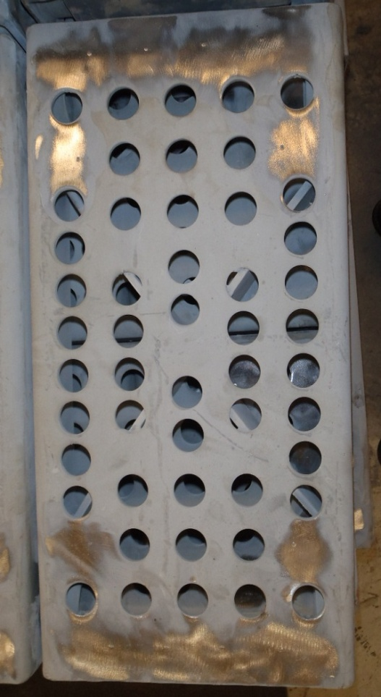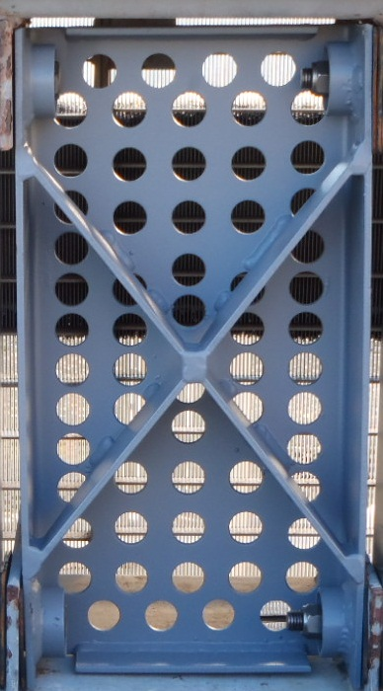
Figure 1 As Found 20% Figure 2 Modified 25% plate

- Drive shaft assembly was not equipped with position indicating transducer boxes. These were installed and tested in accordance with production standards and have been integrated into the Control Room HMI for added reliability.
- JDA screens are equipped with the newer style narrow gap stainless bar screens. Production screens have 1/8” gap and JDA screens have 1/16” gap. According to our Hydraulic Engineers, the velocity is determined by the perforated plates and therefore would not need to be changed out as they would have no impact to water flows. Additionally, we were told that the narrow gap screen is the new standard and is advantageous from a biological standpoint, specifically lamprey. With these recommendations, we kept the newer bar screen. 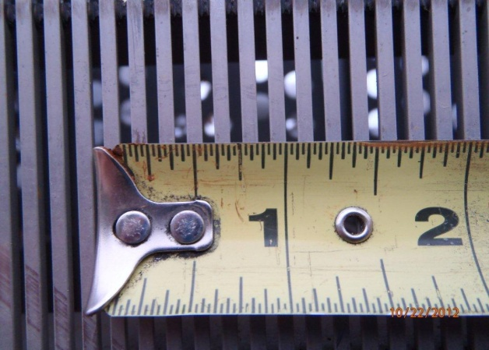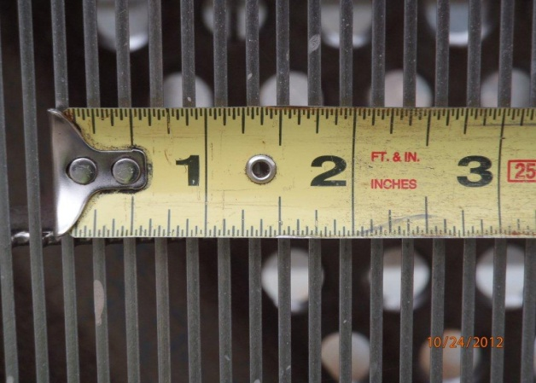
Figure 1 JDA Bar Screen Figure 2 Production Model

